
Muhmmad Mudassar f2023376259
Farooq Haider F2023376255
Muhammad Habee F2023376005
Muhammad Zaeem F2023376012
Gazanfar Ali F2023376013
Machine Learning

A3

4rd Report
K_Means

Importing Required Libraries:
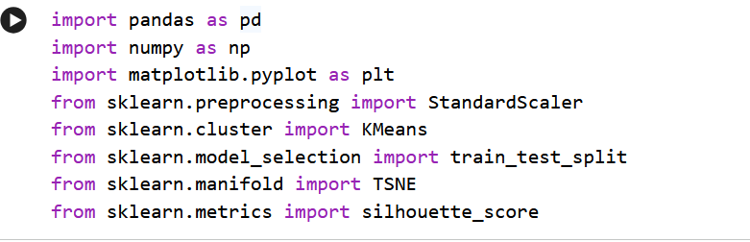

Loading Dataset and Removing Unnecessary Columns:
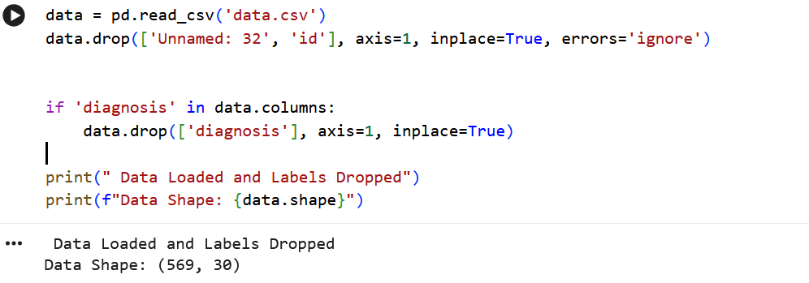

Feature Scaling using Standardization:
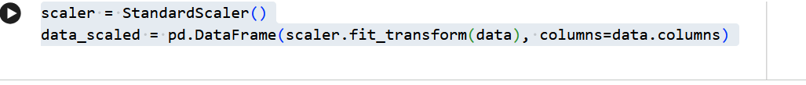

Applying K-Means Clustering and t-SNE Visualization:
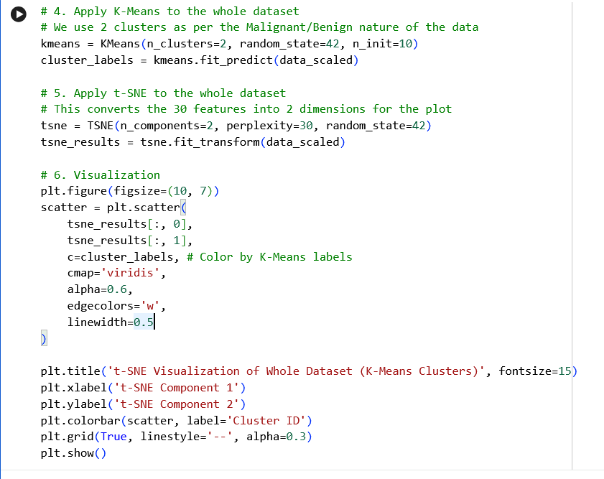

t-SNE Visualization of Whole Dataset (K-Means Clusters):

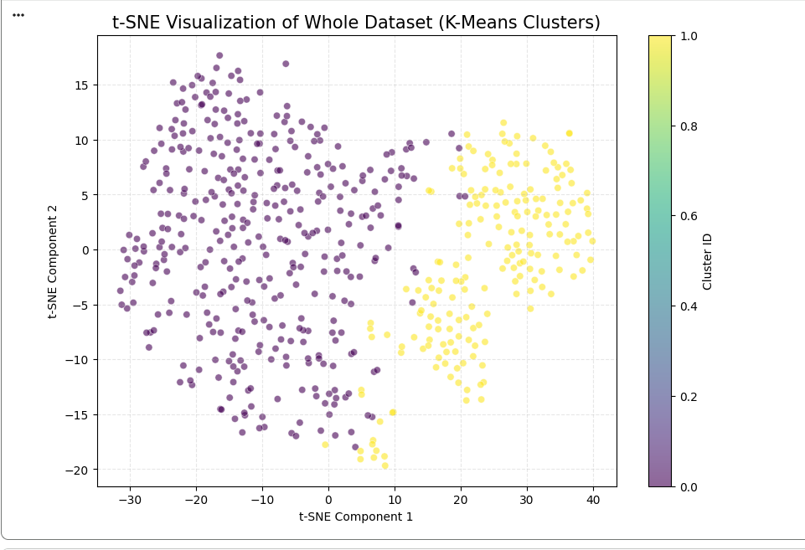

Splitting Data into Training and Testing Sets:

Displaying Training and Testing Data Shapes:
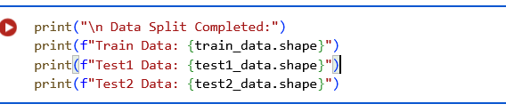

Applying Elbow Method to Determine Optimal Number of Clusters:

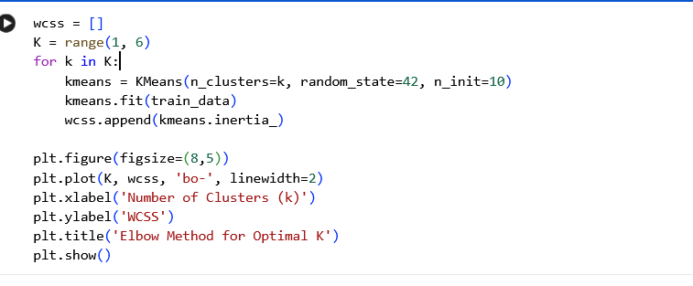

Elbow Method Graph for Optimal Number of Clusters:
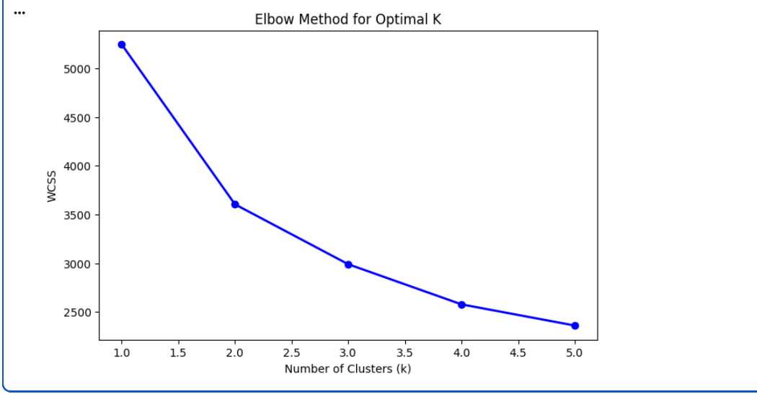

Calculating Silhouette Score to Determine Best Number of Clusters:

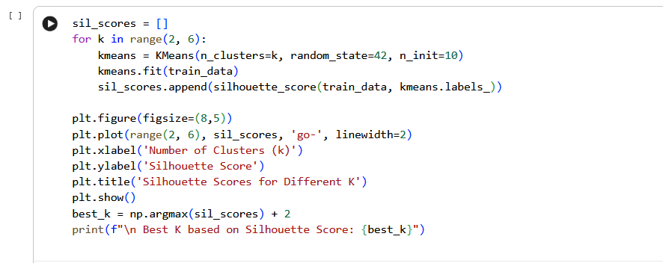

Silhouette Score Graph for Different Values of K:
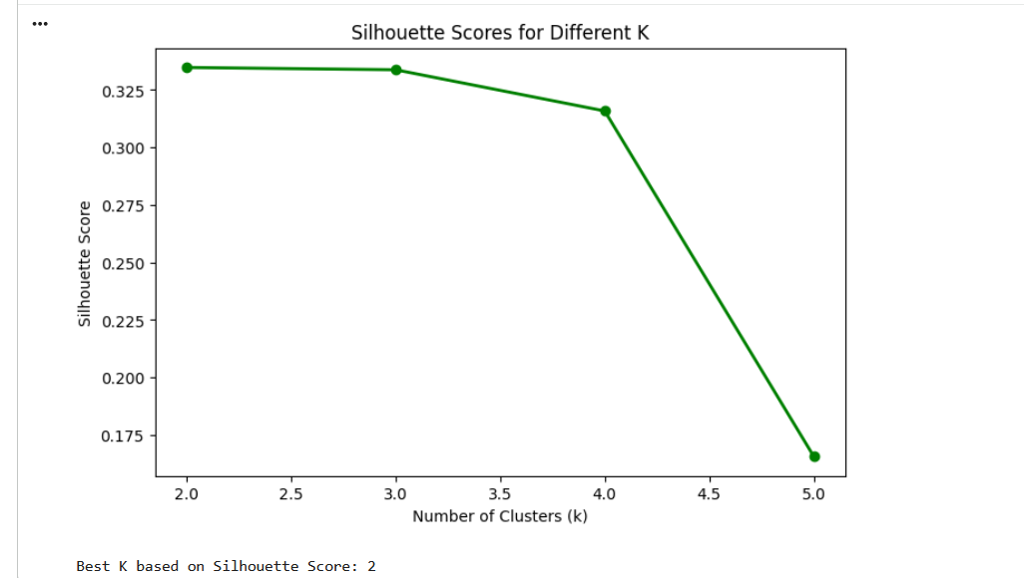

Training Final K-Means Model and Predicting Cluster Labels:

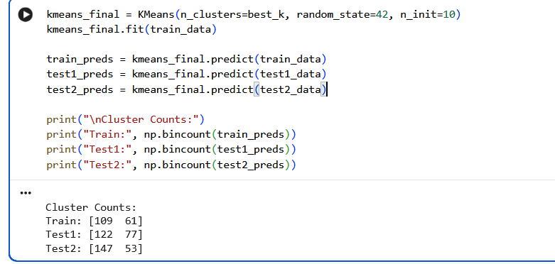

t-SNE Visualization of Training Data Clusters:
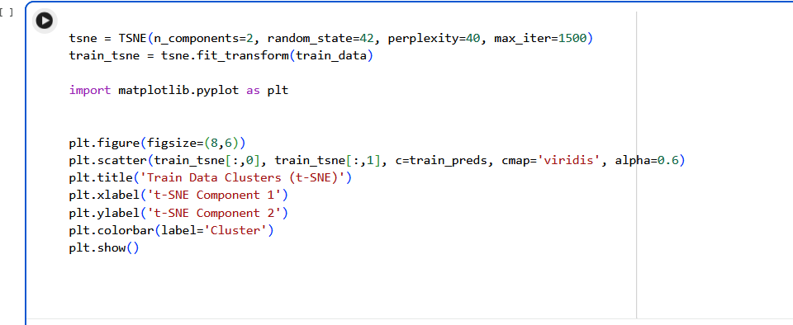

t-SNE Cluster Visualization of Training Data:

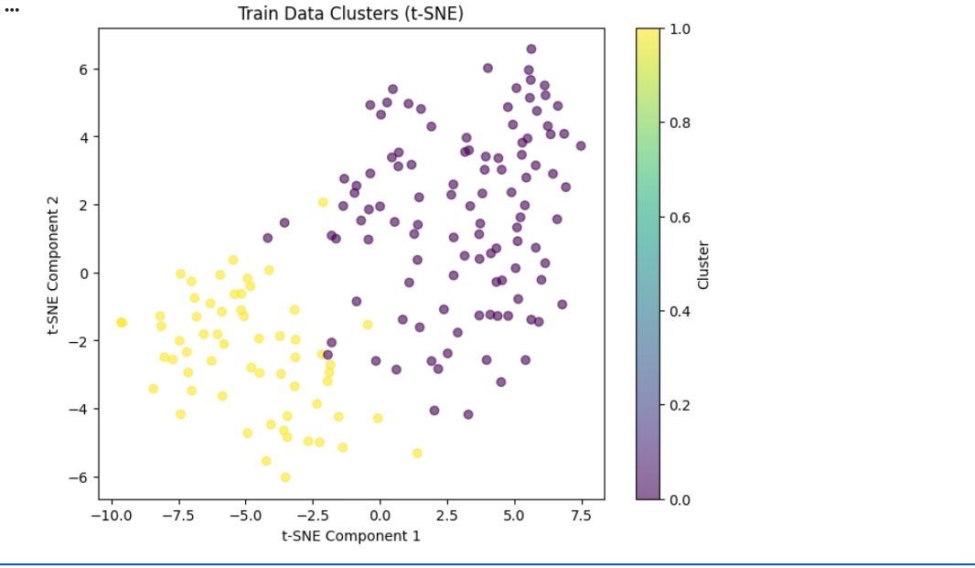

t-SNE Visualization of Test1 Data Clusters:

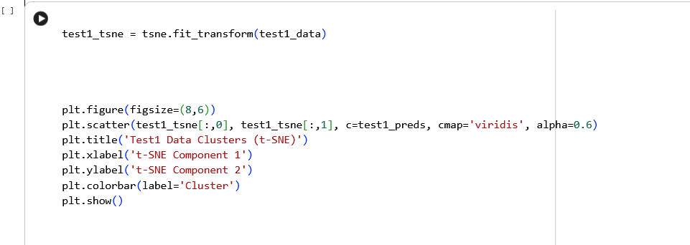

t-SNE Cluster Visualization of Test1 Data:

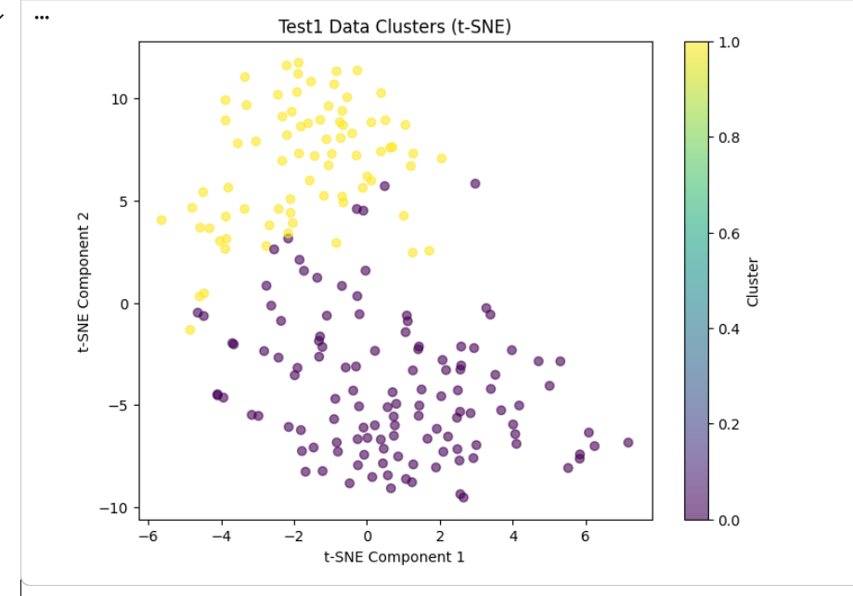

t-SNE Visualization of Test2 Data Clusters:
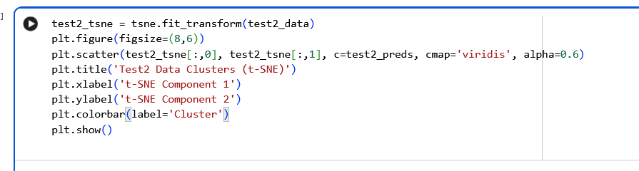

t-SNE Cluster Visualization of Test2 Data:
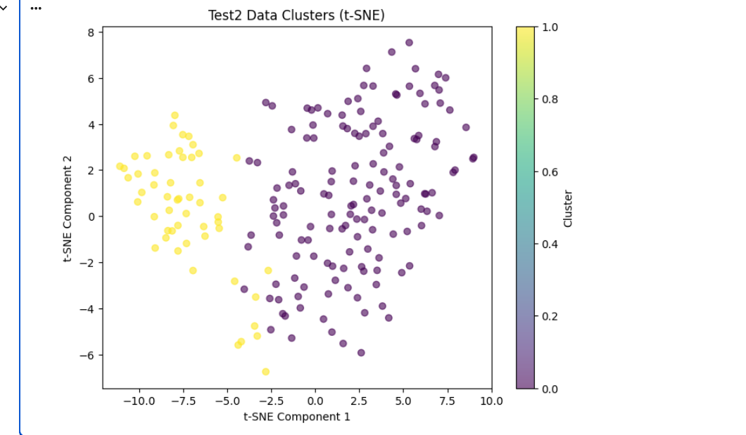

Agglomerative Clustering Setup:

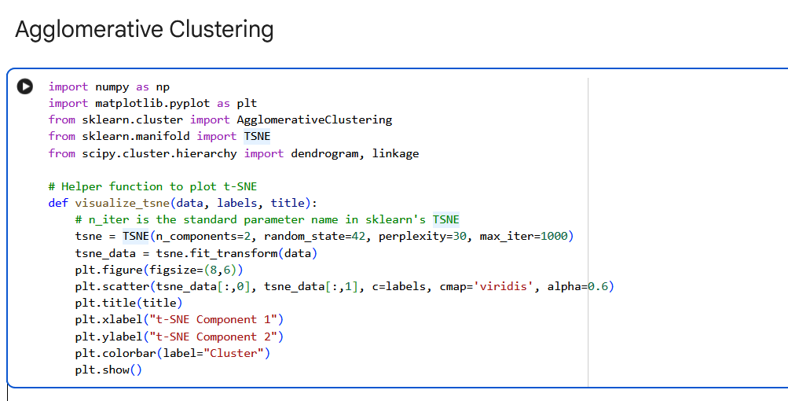

Agglomerative Clustering on Training Data:
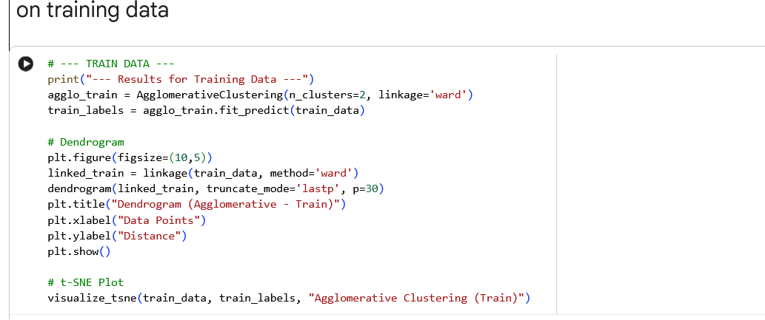

Dendrogram of Training Data (Agglomerative Clustering):
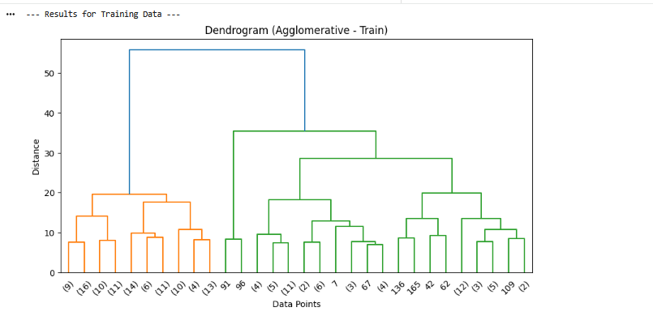

t-SNE Visualization of Agglomerative Clustering (Training Data):

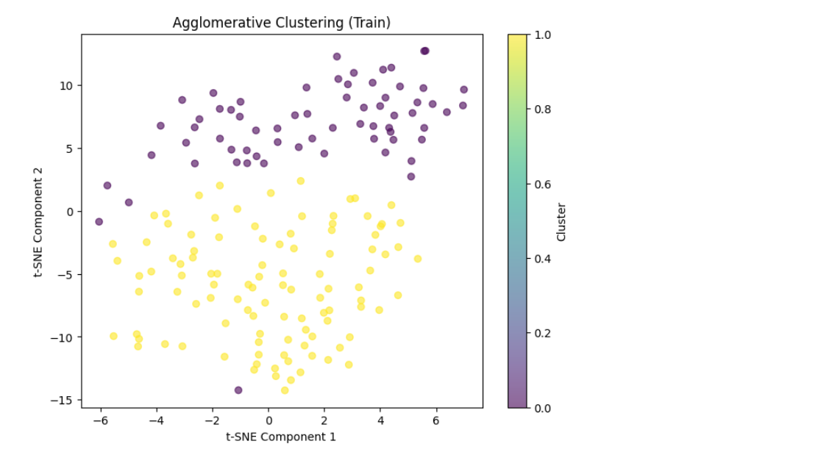

Agglomerative Clustering on Test1 Data:
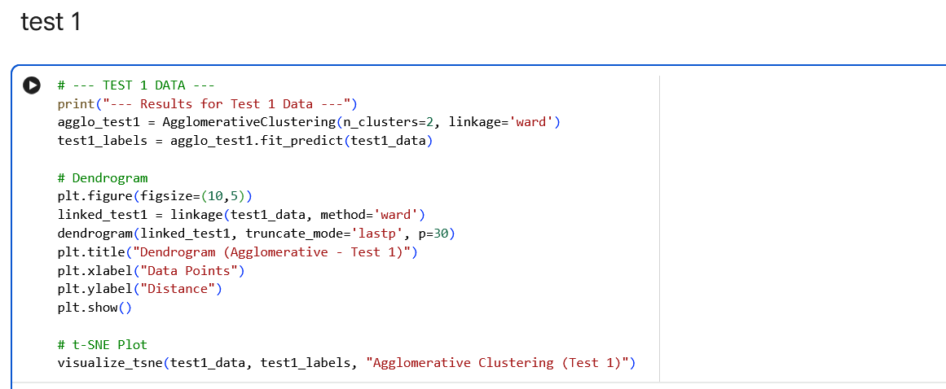

Dendrogram of Test1 Data (Agglomerative Clustering):
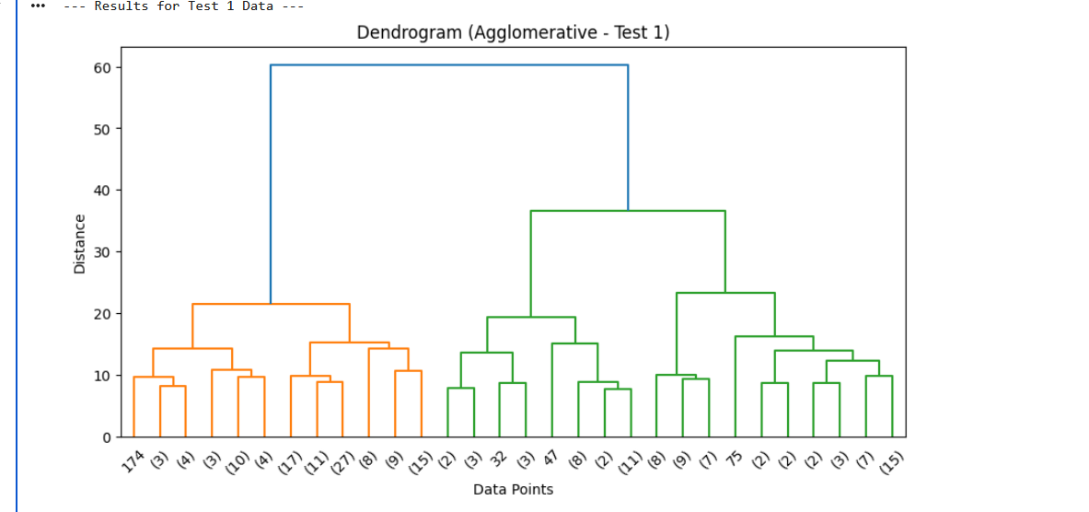

t-SNE Visualization of Agglomerative Clustering (Test1 Data):
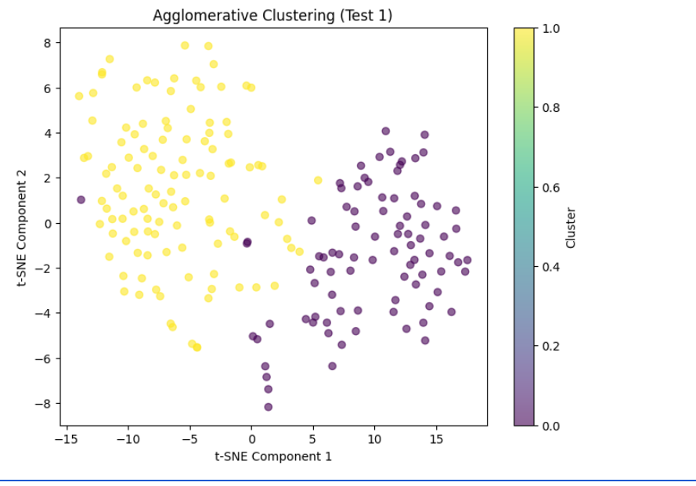

Agglomerative Clustering on Test2 Data:
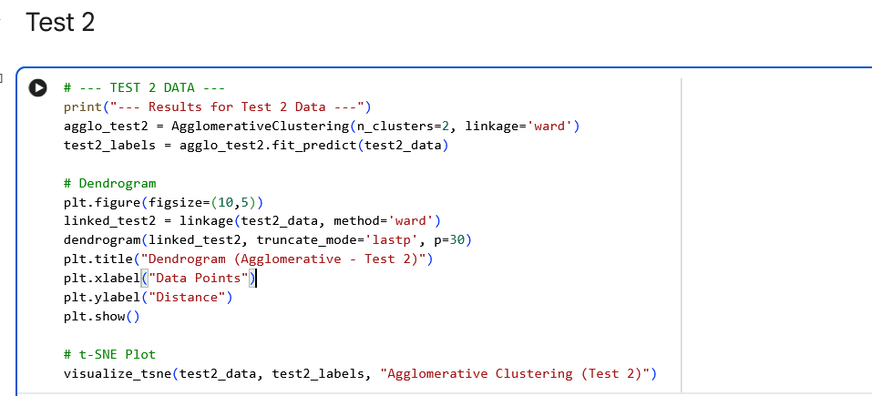

Dendrogram of Test2 Data (Agglomerative Clustering):
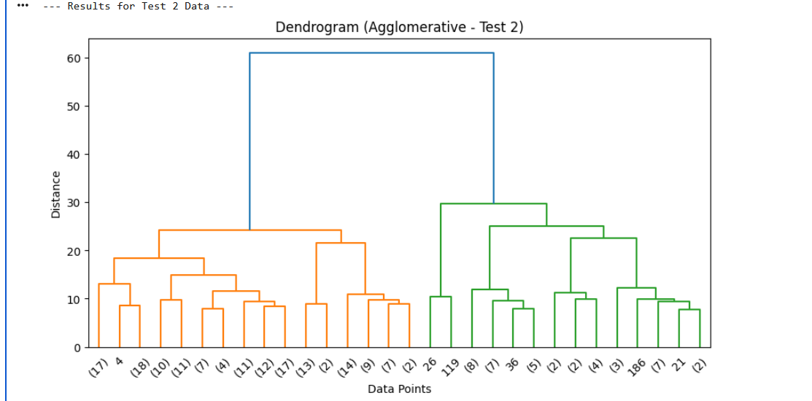

t-SNE Visualization of Agglomerative Clustering (Test2 Data):
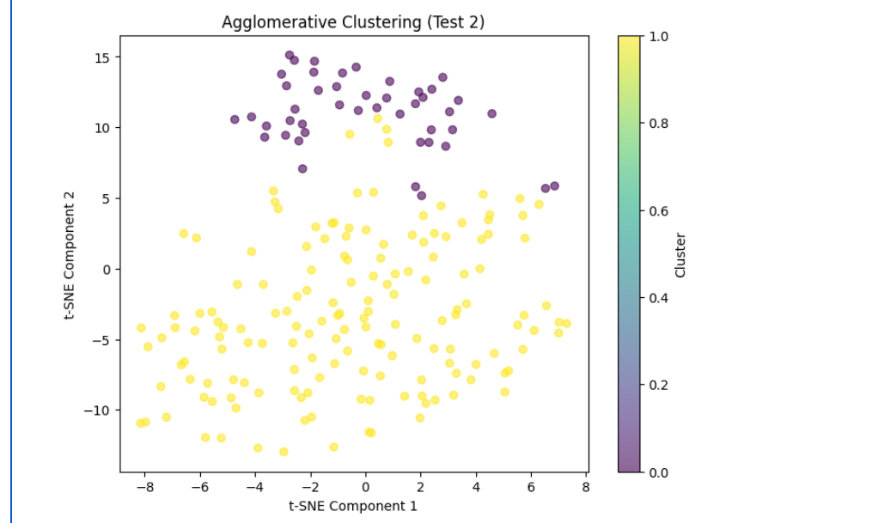

Divisive Clustering on Training Data:
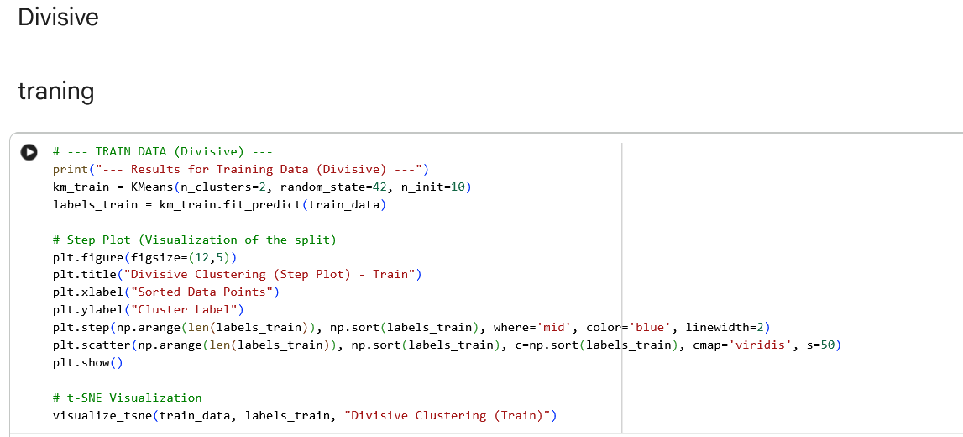

Step Plot of Divisive Clustering (Training Data):
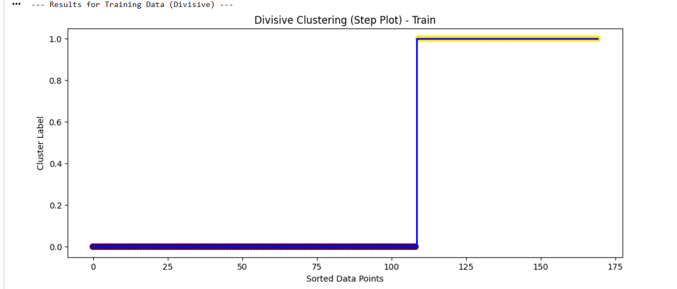

t-SNE Visualization of Divisive Clustering (Training Data):
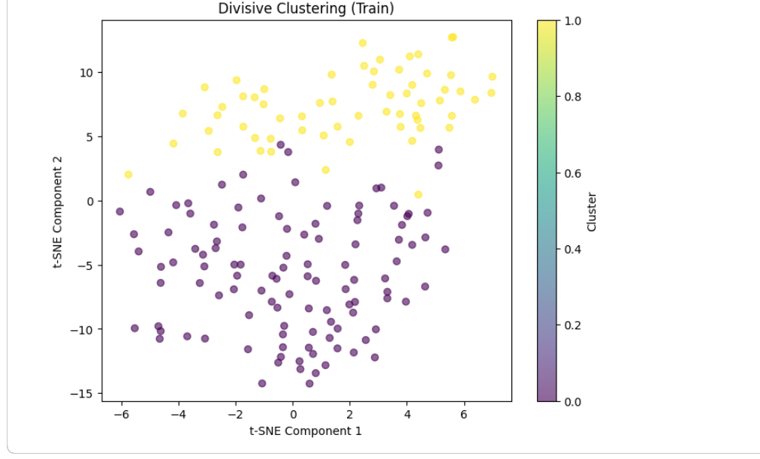

Divisive Clustering on Test1 Data:
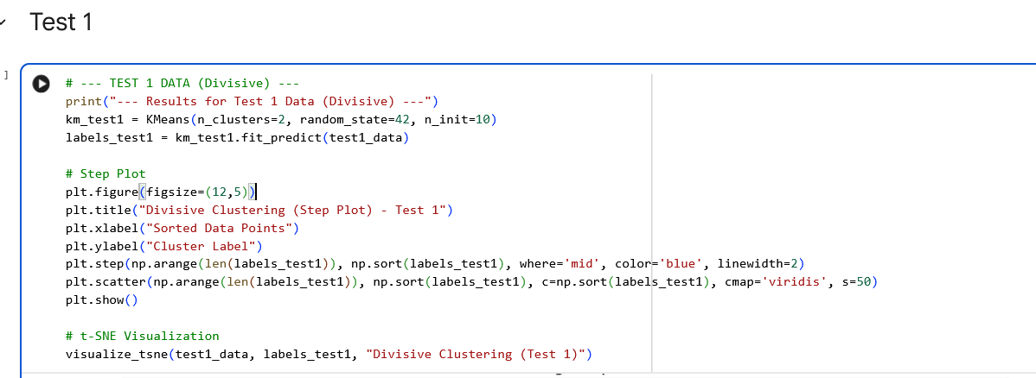

Step Plot of Divisive Clustering (Test1 Data):
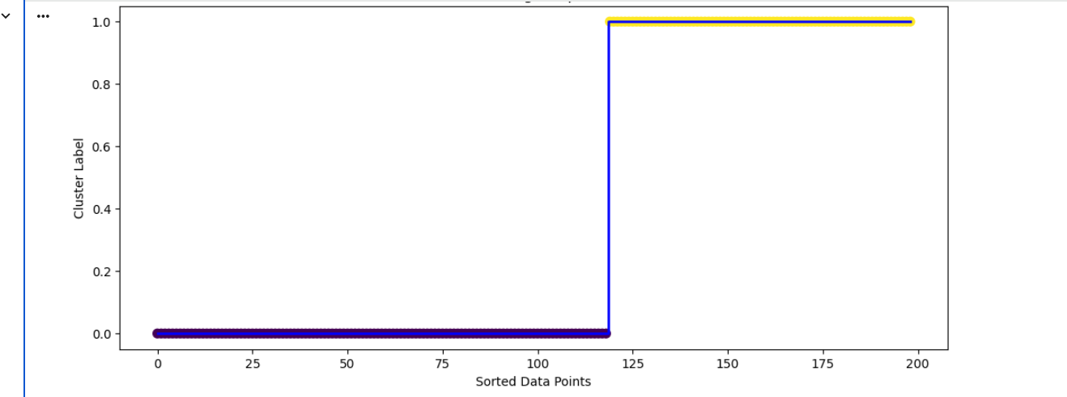

t-SNE Visualization of Divisive Clustering (Test1 Data):
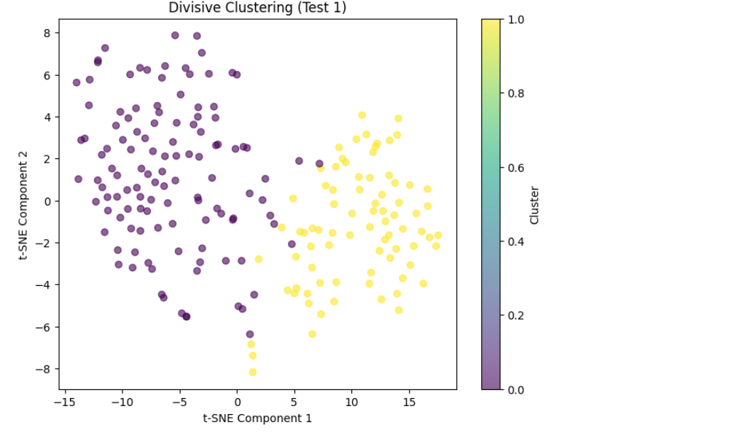

Divisive Clustering on Test2 Data:
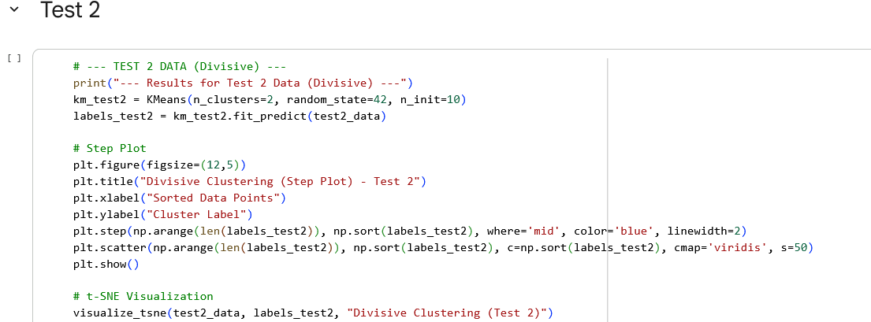

Step Plot of Divisive Clustering (Test2 Data):
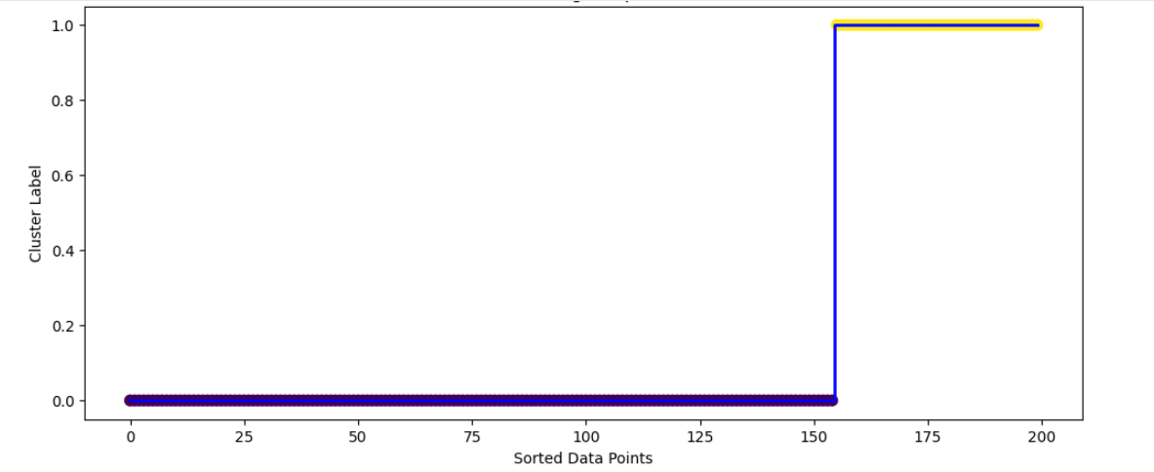

t-SNE Visualization of Divisive Clustering (Test2 Data):
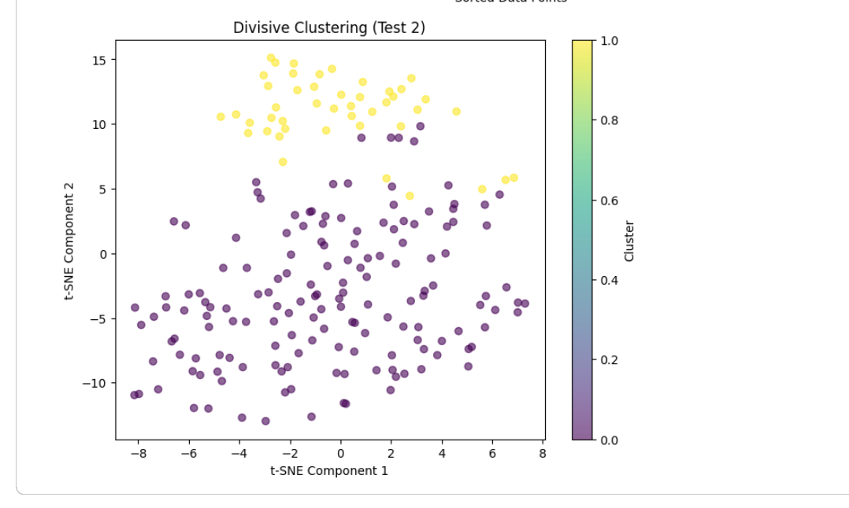

Gaussian Mixture Model (Training Data):
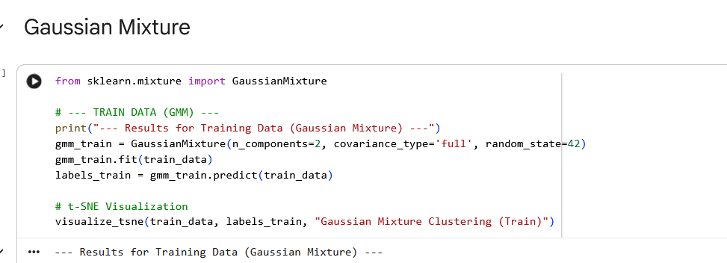

t-SNE Visualization of Gaussian Mixture Clustering (Training Data):
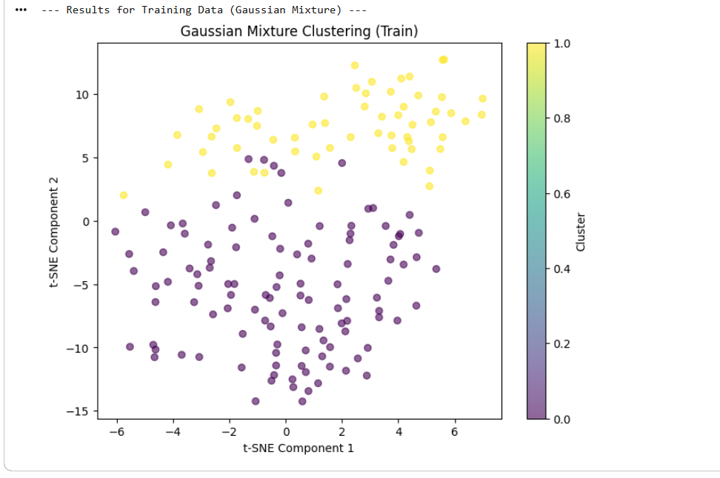

Gaussian Mixture Model (Test1 Data):
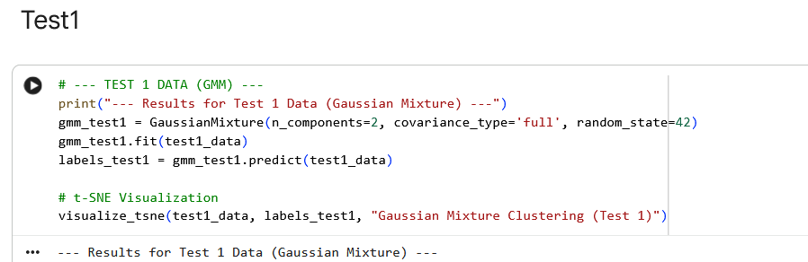

Gaussian Mixture Model (Test2 Data):
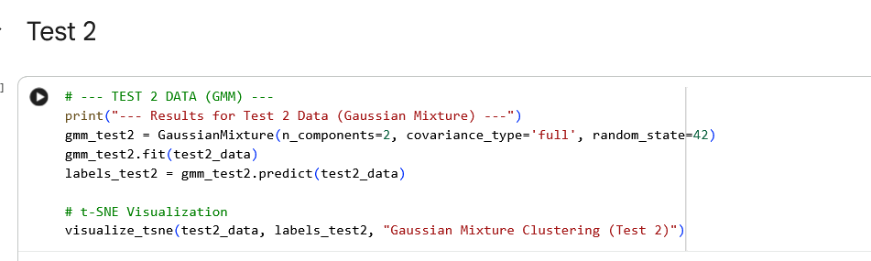

t-SNE Visualization of Gaussian Mixture Clustering (Test2 Data):
